Name: V.Sai Saketh Roll No:2520090023
----------------------------------------------------------------------------------------------
Practical week-4
Step 1 — Create Database
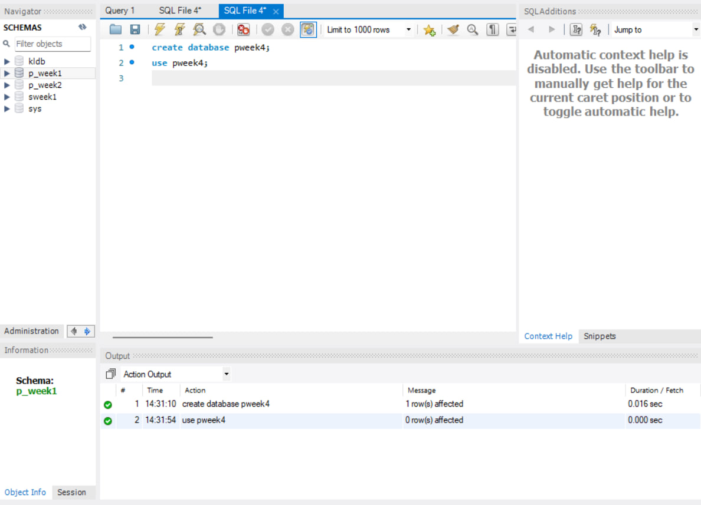

Step 2 — Create Books Table (DDL + Constraints)
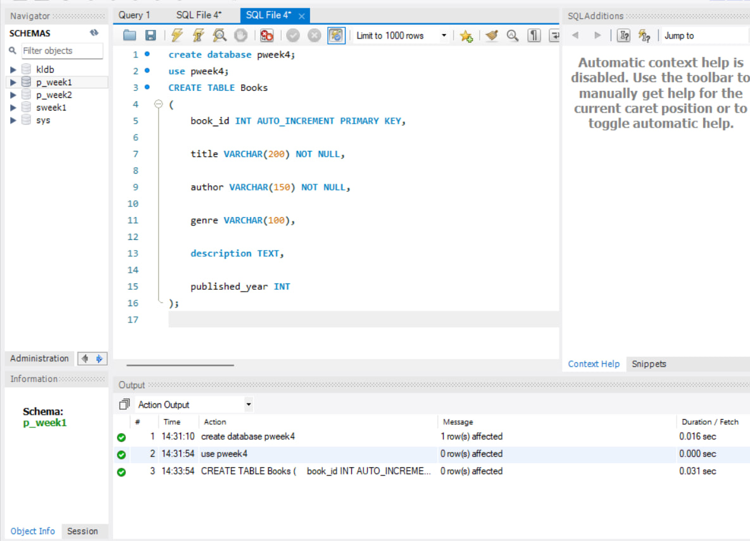

Step 3 — Describe Books Table
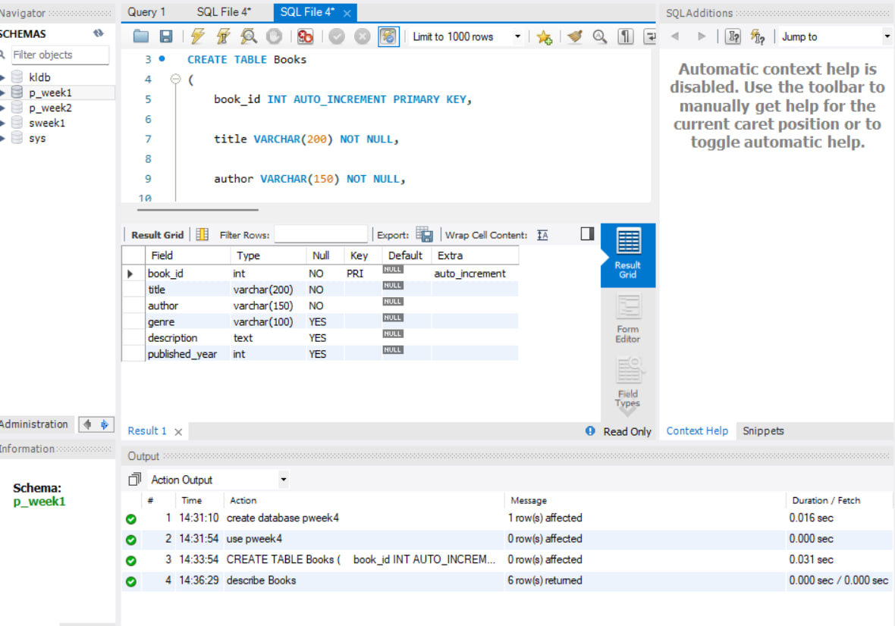
Step 4 — Insert 10 Books and Display
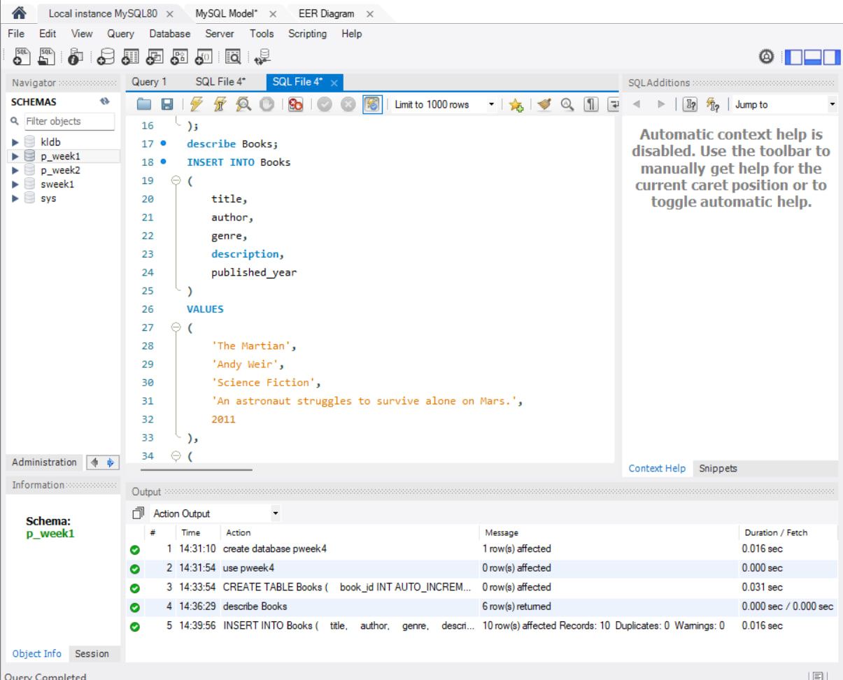

Step 5 — Add Embedding Column (JSON)
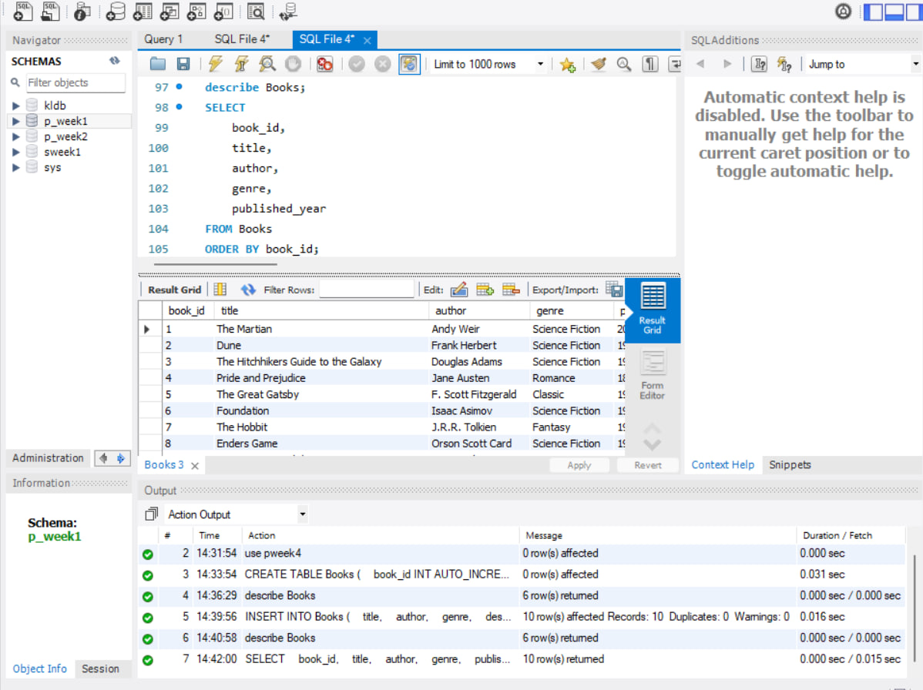
Step 6 — Update Book Embeddings
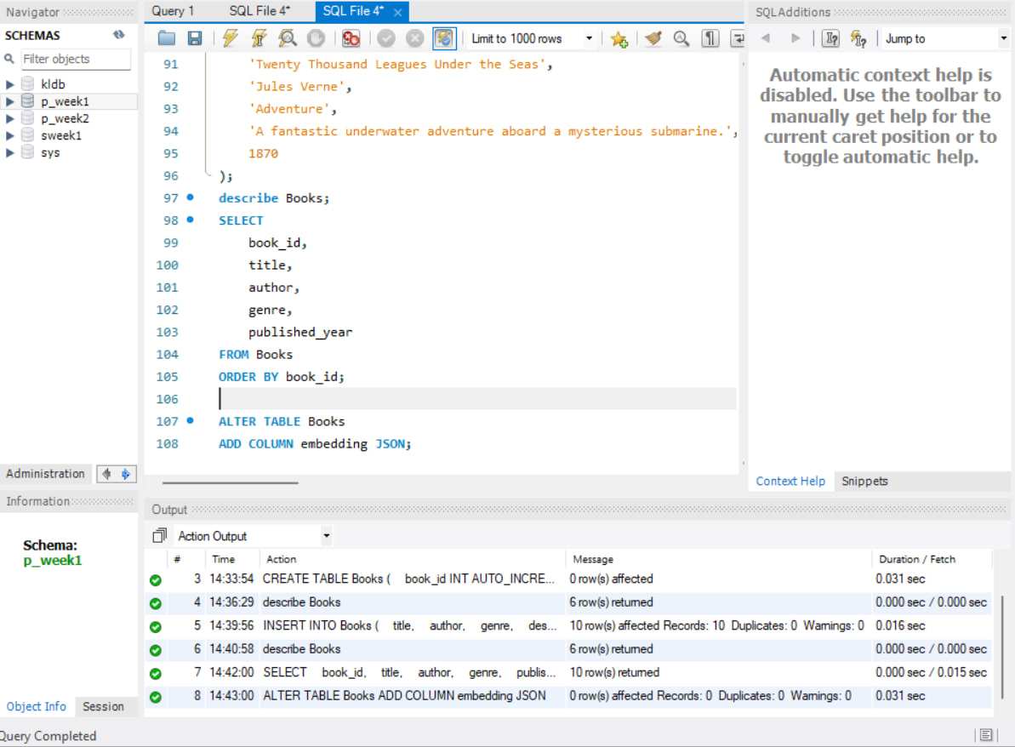

Step 7 — Display Book Embeddings
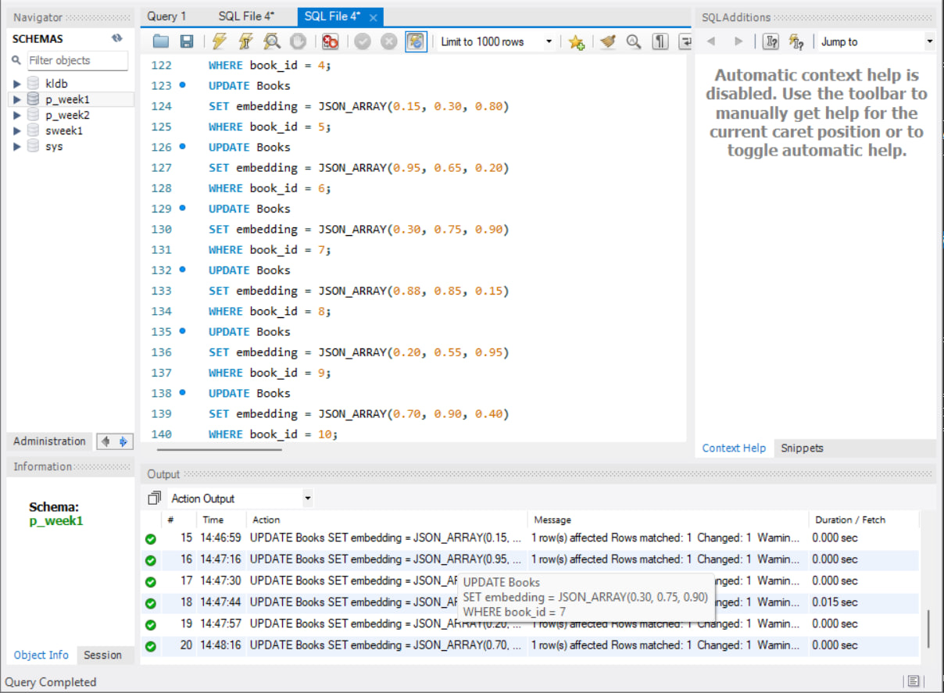
Step 8 — L2 Distance Query
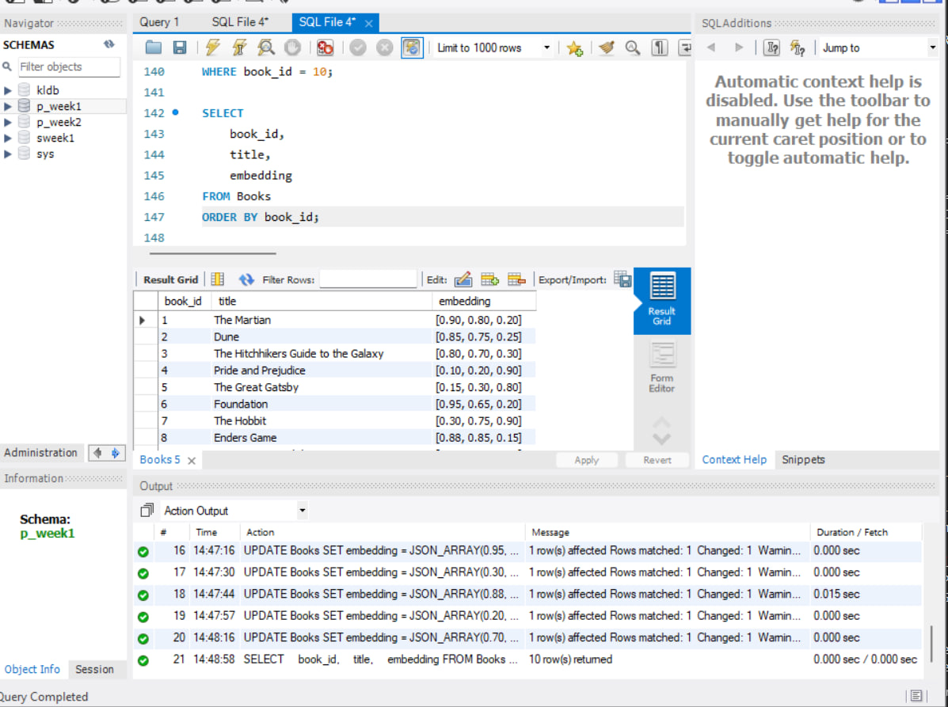

Step 9 — Cosine Similarity Query
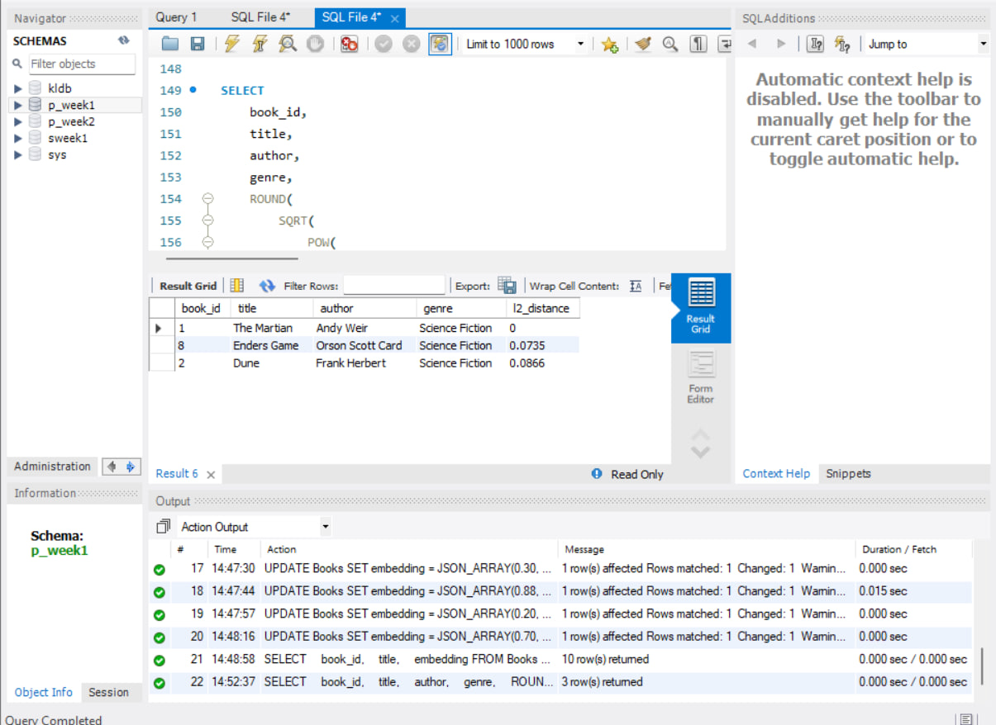
Step 10 — Final Similarity Result
